Performance Evaluation

Evaluation 1

1 client
File Number: 10K
File Range: 1KB
Test_register | Test_lookup | Test_obtain
0:00:46.787718 | 0:00:29.754574 | 0:00:03.436828

Average Time for 10K operations:
Test_register: 0:00:46.787718 s
Test_lookup: 0:00:29.754574 s
Test_obtain: 0:00:03.436828 s
Average Time for 1 operation:
Test_register: 46.787718 x 10⁻⁵ s
Test_lookup: 29.754574 x 10⁻⁵ s
Test_obtain: 3.436828 x 10⁻⁵ s
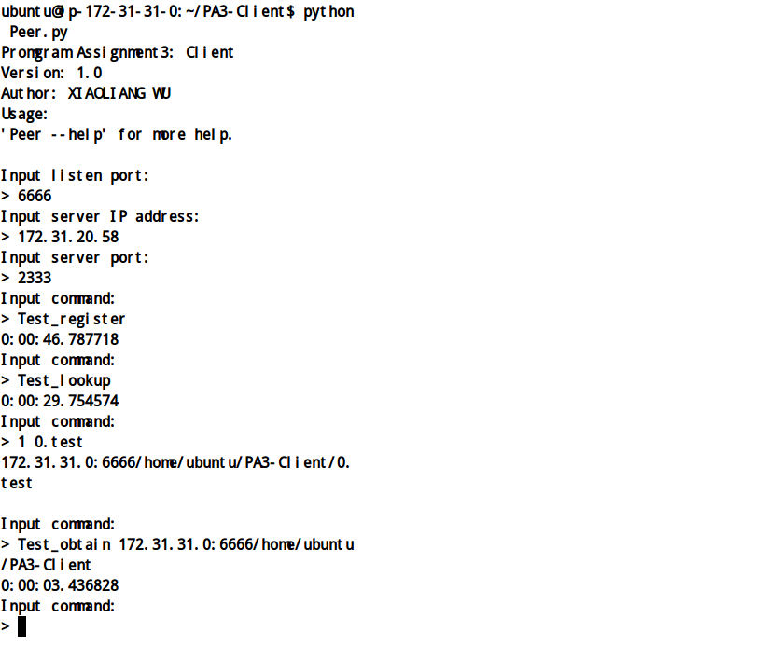

2 clients
File Number: 10K
File Range: 1KB
Test_register | Test_lookup | Test_obtain
0:00:50.735557 | 0:00:33.989532 | 0:00:08.935088
0:00:58.366677 | 0:00:33.814004 | 0:00:08.943831

Average Time for 10K operations:
Test_register: 54.551117 s
Test_lookup: 33.901768 s
Test_obtain: 8.939459.5 s
Average Time for 1 operation:
Test_register: 54.551117 x 10⁻⁵ s
Test_lookup: 33.901768 x 10⁻⁵ s
Test_obtain: 8.939459.5 x 10⁻⁵ s
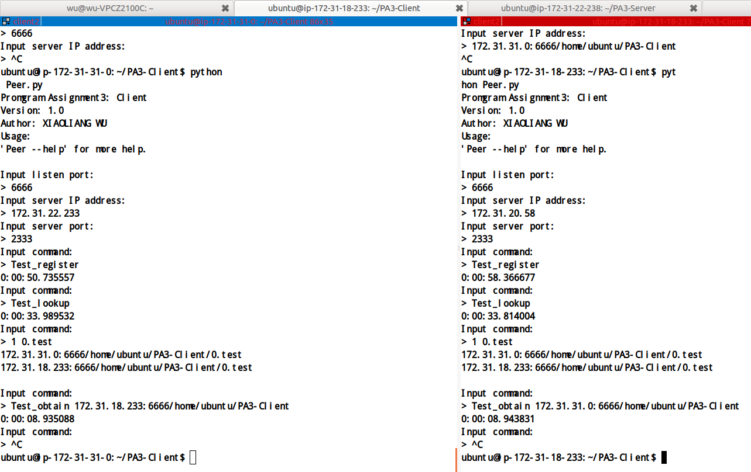

4 clients
File Number: 10K
File Range: 1KB
Test_register | Test_lookup | Test_obtain
0:00:42.345876 | 0:00:50.024007 | 0:00:17.431240
0:01:02.609038 | 0:00:47.408819 | 0:00:08.809214
0:00:46.988712 | 0:00:49.197561 | 0:00:08.266136
0:01:02.162448 | 0:01:05.806423 | 0:00:16.762581

Average Time for 10K operations:
Test_register: 53.5265185 s
Test_lookup: 53.1092025 s
Test_obtain: 12.81729275 s
Average Time for 1 operation:
Test_register: 53.5265185 x 10⁻⁵ s
Test_lookup: 53.1092025 x 10⁻⁵ s
Test_obtain: 12.81729275 x 10⁻⁵ s
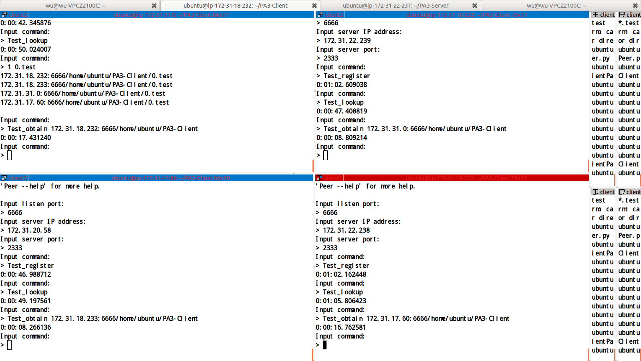

8 clients
File Number: 10K
File Range: 1KB
Test_register | Test_lookup | Test_obtain
0:00:43.270973 | 0:01:26.168643 | 0:00:11.639198
0:00:54.592377 | 0:01:25.079346 | 0:00:15.464951
0:01:02.419746 | 0:01:23.609545 | 0:00:08.090359
0:00:50.712737 | 0:01:35.807770 | 0:00:08.817620
0:00:54.637873 | 0:01:22.259105 | 0:00:08.894615
0:00:50.663217 | 0:01:27.190370 | 0:00:17.094383
0:00:58.166328 | 0:01:36.755483 | 0:00:11.354870
0:00:54.397964 | 0:01:24.112065 | 0:00:08.718804

Average Time for 10K operations:
Test_register: 53.607651875 s
Test_lookup: 86.811939875 s
Test_obtain: 11.25935 s
Average Time for 1 operation:
Test_register: 53.607651875 x 10⁻⁵ s
Test_lookup: 86.811939875 x 10⁻⁵ s
Test_obtain: 11.25935 x 10⁻⁵ s
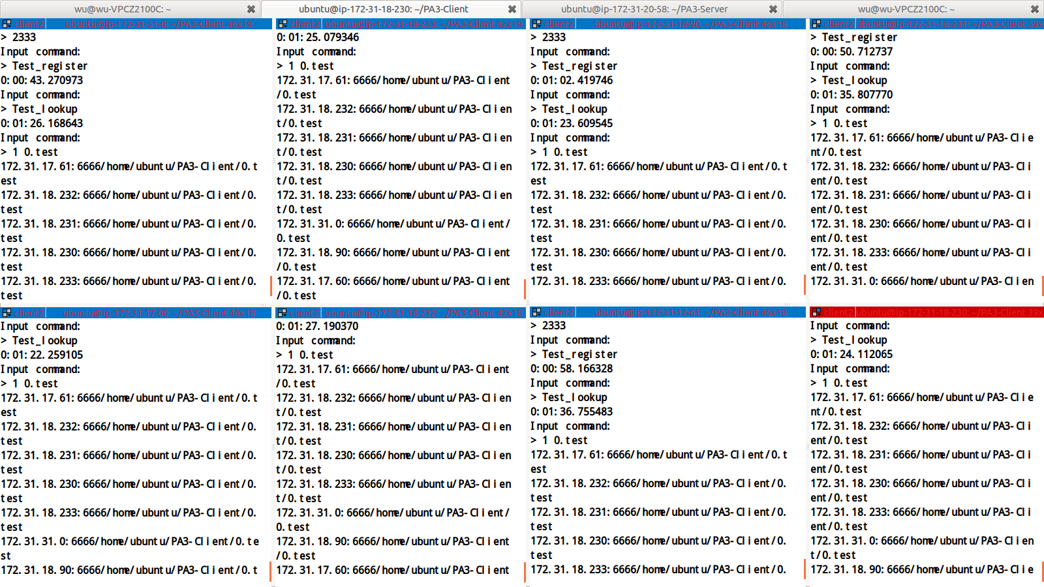

Figures
Time & Client number relation

Explanation
As the scale improve, the efficiency of system is decreasing. First, when more clients access server at the same time, the load of server is increasing, so the server need more time to handle requests from clients. Second, when the scale of hash table become bigger, servers need more time to register and look up pairs.

Evaluation 2

1 KB
File number: 100K
 | Time
Node1 | 0:02:13.264636
Node2 | 0:01:35.922974
Node3 | 0:02:05.822766
Node4 | 0:00:51.053157
Node5 | 0:01:36.489386
Node6 | 0:02:49.688847
Node7 | 0:01:55.696130
Node8 | 0:03:08.237809

Average Time for 100K files: 122.021963125 s
Average Throughput: 819.524595728 KB/s
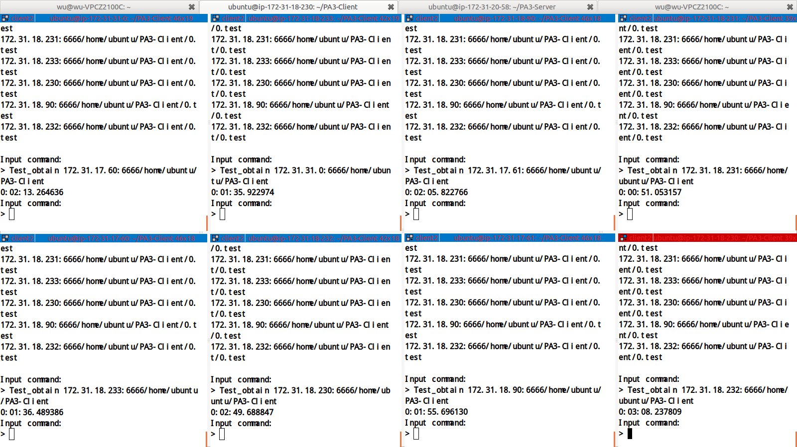

10 KB
File number: 80K
 | Time
Node1 | 0:01:49.883668
Node2 | 0:02:28.649089
Node3 | 0:01:28.335286
Node4 | 0:02:34.653708
Node5 | 0:01:52.001100
Node6 | 0:03:08.680727
Node7 | 0:03:16.063790
Node8 | 0:01:49.252980

Average Time for 80K files: 138.4400435 s
Average Throughput: 5778.67486729 KB/s
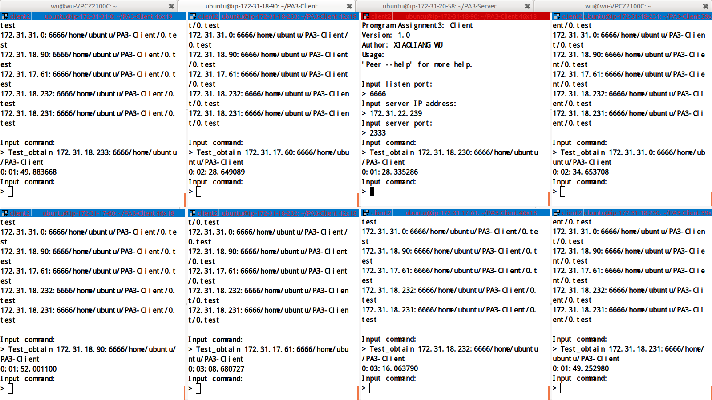

100 KB
File number: 20K
 | Time
Node1 | 0:01:26.257927
Node2 | 0:01:36.045714
Node3 | 0:02:02.055532
Node4 | 0:02:02.255715
Node5 | 0:01:34.489039
Node6 | 0:01:39.156819
Node7 | 0:01:34.397556
Node8 | 0:01:49.803016

Average Time for 20K files: 43.05766475 s
Average Throughput: 46449.337455069 KB/s
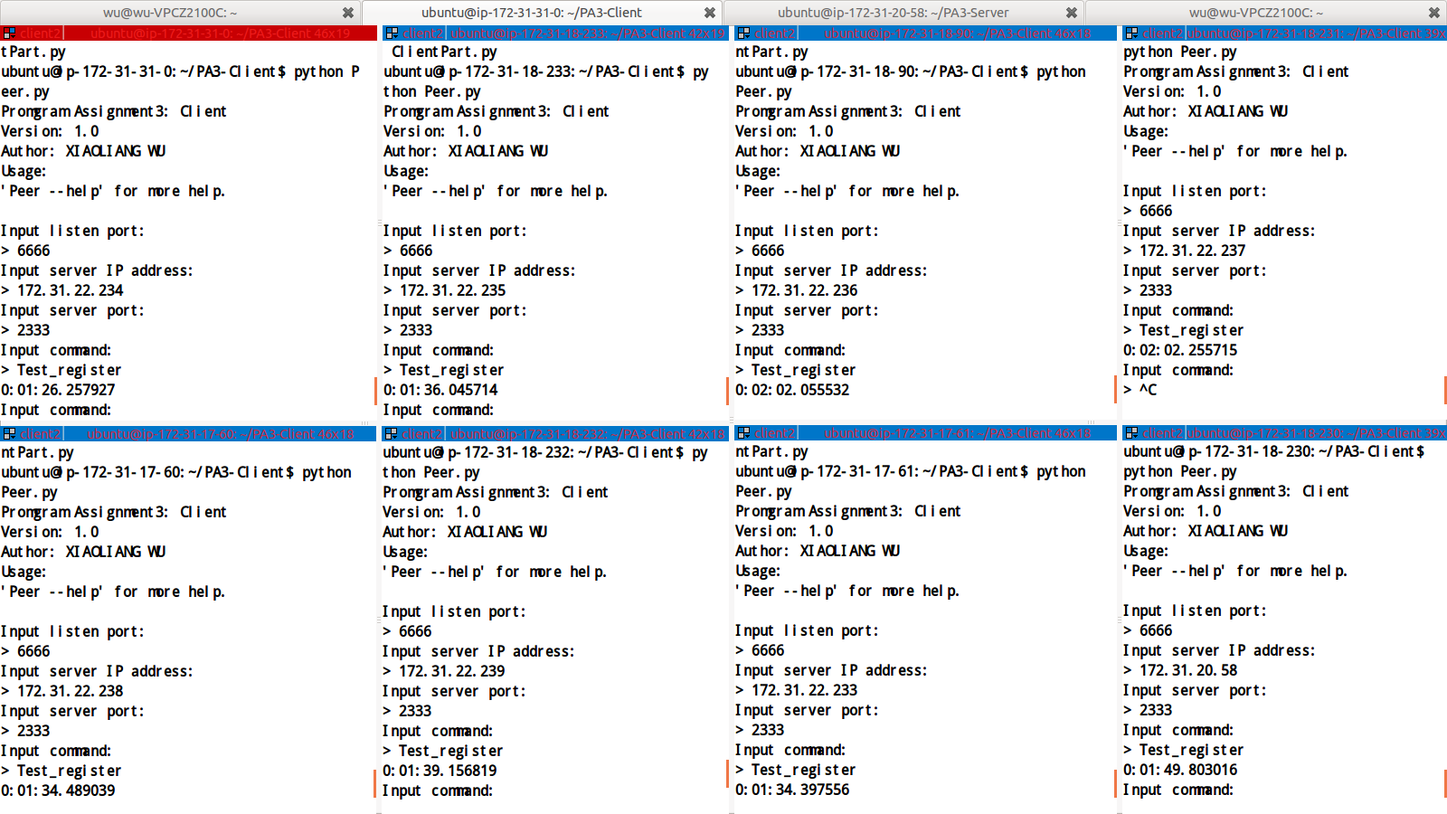

1 MB
File number: 3K
 | Time
Node1 | 0:01:09.964682
Node2 | 0:00:56.776704
Node3 | 0:00:49.253483
Node4 | 0:00:50.263704
Node5 | 0:01:28.497995
Node6 | 0:01:03.167623
Node7 | 0:01:09.803741
Node8 | 0:00:58.640517
Average Time for 3K files: 63.296056125 s
Average Throughput: 48533.829563303 KB/s
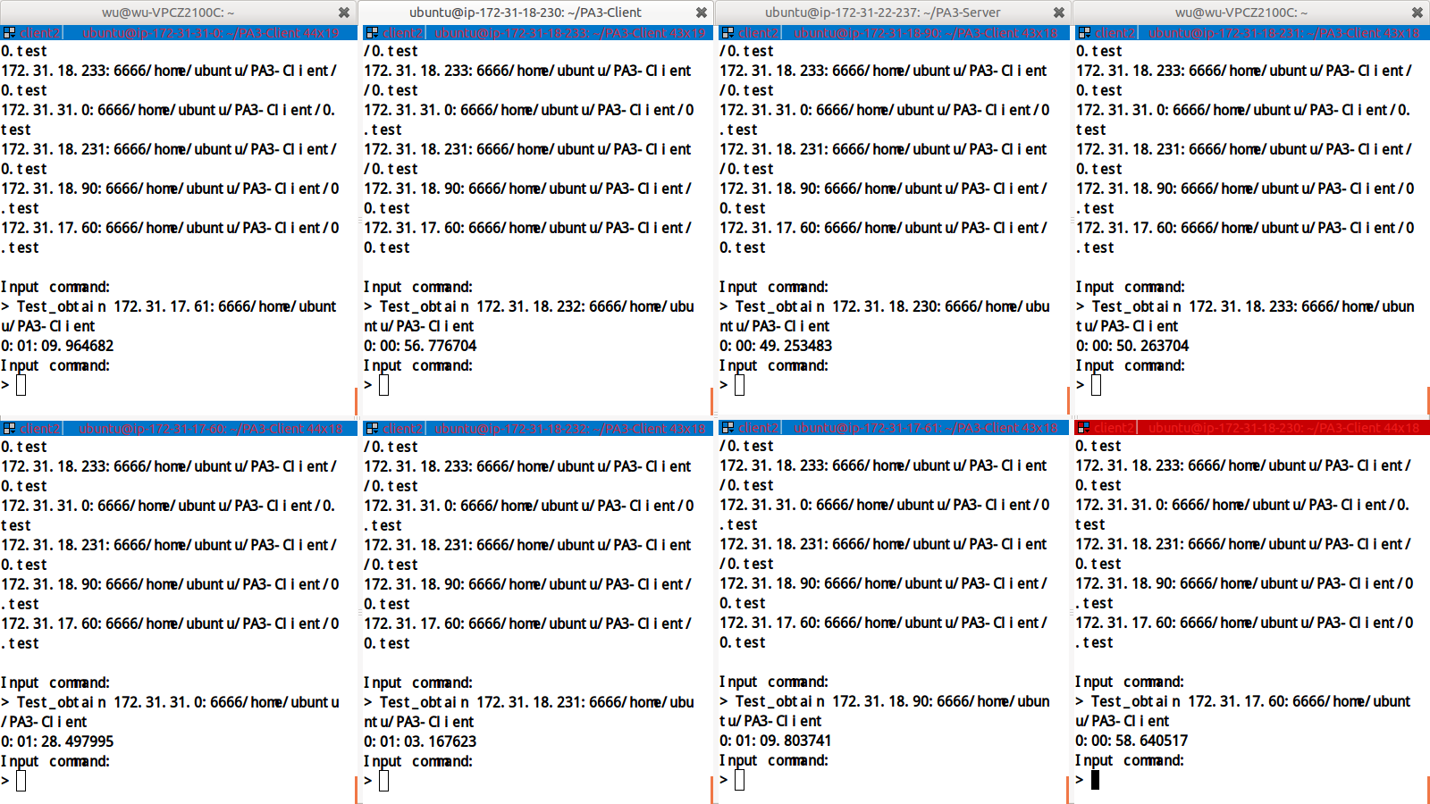

10 MB
File number: 300
 | Time
Node1 | 0:01:00.721909
Node2 | 0:00:50.932809
Node3 | 0:01:10.035846
Node4 | 0:01:20.841087
Node5 | 0:00:52.217926
Node6 | 0:00:50.598904
Node7 | 0:00:58.204081
Node8 | 0:01:20.947353

Average Time for 300 files: 63.062489375 s
Average Throughput: 48713.586007244 KB/s
Image damaged. Sorry!

100 MB
File number: 30
 | Time
Node1 | 0:00:48.457463
Node2 | 0:00:48.184282
Node3 | 0:01:31.356267
Node4 | 0:00:48.582262
Node5 | 0:00:54.424906
Node6 | 0:01:35.128004
Node7 | 0:01:08.924798
Node8 | 0:00:48.380435
Average Time for 30 files: 62.929802125
Average Throughput: 48816.298419276
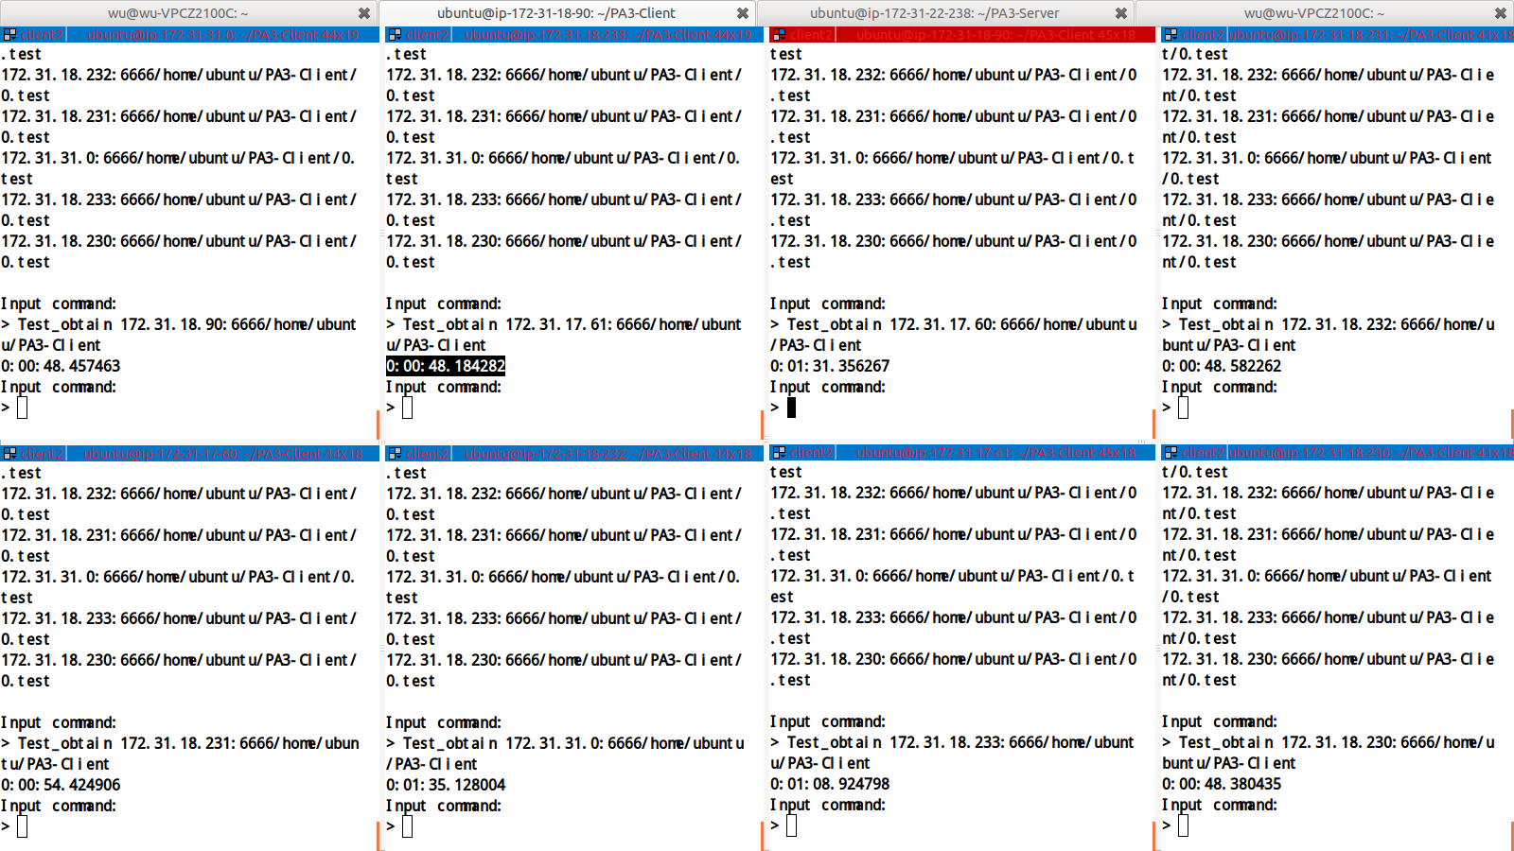

1 GB
File number: 3
 | Time
Node1 | 0:00:52.314314
Node2 | 0:00:52.599806
Node3 | 0:01:37.317310
Node4 | 0:00:49.659276
Node5 | 0:00:51.350218
Node6 | 0:01:36.770351
Node7 | 0:01:00.670450
Node8 | 0:00:49.389992
Average Time for 3 files: 58.7718193333 s
Average Throughput: 53524.427790134 KB/s
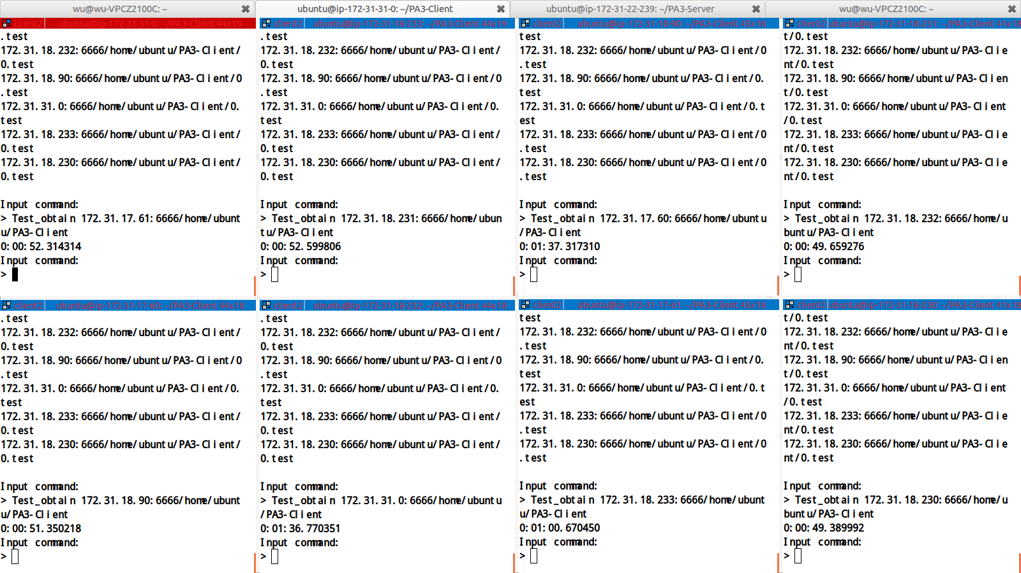

Figures
Throughput & File size relation

Explanation
As the size of file increasing, the throughput of client is increasing, and gradually the throughput become stable. Because this system use TCP as transportation protocol, if the size of file is small and the bandwidth is large, clients will cost more time on establish connection. When the size of file become large enough, the time that is used to establish connection occupy only a few of transfer time, so it cannot limit the throughput. However, it is a limited bandwidth network, so the throughput gradually become stable.

